Track : NIKE ONLINE SHOP SYSTEM

A Project Presented to the

Faculty of the College of Computer Studies Northern Bukidnon State College

In Partial Fulfillment

of the Requirements for the Degree Bachelor of Science in Information Technology

Lucero Kim M.
Madria Jenny C.

May 2026

Page

1

TABLE OF CONTENTS

Page

Contents
TABLE OF CONTENTS 1

Introduction 2
  - Overview 2
ENTITY RELATIONSHIP DIAGRAM 3
SQL JOIN INTEGRATION 5
  - Join Connection 5
EMPLEMENTATION 7
  - Technologies Used 7
  - Code Snippets and Functions 7
FEATURES 9
4.1 System Features 9
1.
2.
3.
4.
MANUAL
5.1 User Instructions
5.1.1 Sign Up
5.1.2 Log In
5.1.3 Dashboard
5.1.4
5.1.5
5.1.7 Log Out

INTRODUCTION

Page

2

1.1 Overview

Online shopping has become one of the easiest and most convenient ways for
People to buy products. However, some online stores still experience problems in
Managing products, customer orders, and transactions properly. Because of this,
TRACK: NIKE ONLINE SHOP SYSTEM was created to provide a simple, organized,
and user-friendly online shopping platform.

The system allows customers to browse Nike products, register accounts, log in, and
place orders online. It also helps administrators manage products, monitor orders, and keep
customer information organized. The project is designed to make shopping faster, easier, and
more convenient for users.

The system includes the following features:
- Product Management: Displays Nike products with complete details such as price, size, and availability.
- Order Tracking: Allows customers and administrators to monitor orders and transactions easily.
- User Authentication: Provides secure account registration and login for users.
- Data Management: Keeps records of products, customer details, and transactions organized and accurate.
Overall, TRACK: NIKE ONLINE SHOP SYSTEM helps improve the online shopping experience by providing a secure, efficient, and easy-to-use platform for both customers and administrators.

ENTITY RELATIONSHIP DIAGRAM

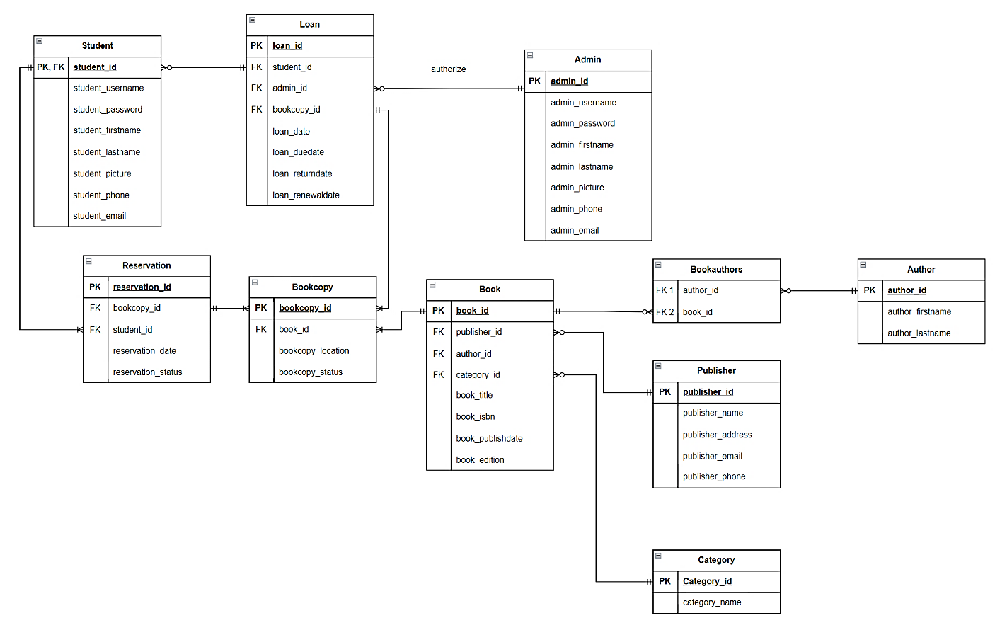

Figure 1: ERD
Page

PAGE

(Put here the description/narrative of your ERD. Make sure to explain all the tables and their relationship with other table)

SQL Join Integration

Sample code showing the join used (put comment):
SELECT column_name(s)
FROM table1
INNER JOIN table2
ON table1.column_name = table2.column_name;
Page

PAGE

IMPLEMENTATION
Page

PAGE

  - Technologies Used

Mention the technologies used in the project.

  - Key Code Snippets and Functions

Share important code snippets or functions that play a crucial role in the implementation.
Example: Joins
Insertion (DML)

FEATURES
Page

PAGE

  - System Features

List and briefly explain the main features of the personal finance management system.

Add new contacts Delete contacts
Update existing contacts Retrieve deleted contacts Search for contacts

  - User Instructions

MANUAL
Page

PAGE

Provide simple and formal instructions on how to use the personal finance management system with image.

Adding a Contact: Click on the "ADD NEW" button and enter the required information. Deleting a Contact: Select a contact from the table and click the "DELETE" button.
Updating a Contact: Select a contact from the table, click the "UPDATE" button, modify the information, and click "OK."
Retrieving Deleted Contacts: Click on the "RETRIEVE" button to restore a deleted contact.
Searching for a Contact: Click on the "SEARCH" button, enter the name, and view the search result in a new table.

